Addition Crossword Puzzles
Follow the (addition and equal signs) to ensure your sums make sense!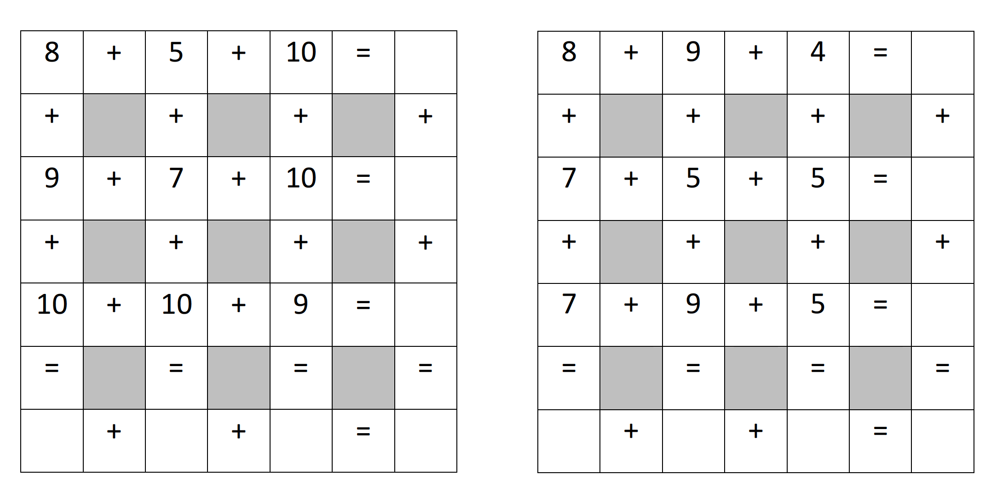
For more challenging questions, try the crosswords below!
