RH Data Activity: Part 2

Using the data we collected last week, answer the following questions. Make sure to support your answers with mathematical thinking. If you need to use a calculator, you may.
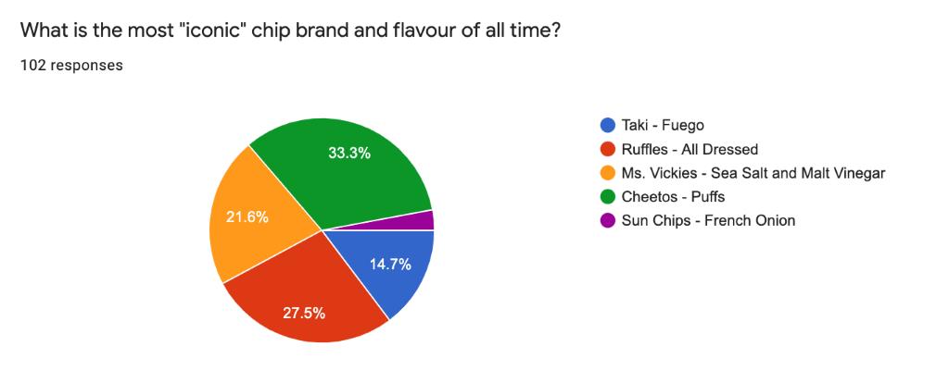
a) Approximately, what percent of people thought Sun Chips – French Onion was the most iconic chip brand and flavour of all time?

b) Read the graph and the surrounding information carefully. If we have each percentage and there were 102 responses in total, how many people voted for each category? Read the example and follow the pattern. (**you may need to round up or round down to the nearest whole number)
For example: Cheetos
Step 1 → 33.3% ÷ 100 = 0.333 (this decimal number represents $\frac{number of votes in a category}{total number ofresponses}$ )
Step 2 → 0.333 x 102 = 33.9 ≈ 34 people voted for Cheetos (we round up to 34 since you can’t have .9 of a person)

# of people who voted for Taki - Fuego = _______________
# of people who voted for Ruffles - All Dressed = _________________
# of people who voted for Ms. Vickies - Sea Salt and Malt Vinegar = __________________
# of people who voted for Cheetos - Puffs = ____________

c) Using the numbers you just acquired, what is the “data set” (may need to refer to “Graph Intro Week 7” notes)

d) What is the ratio of people who voted for flat chips to people who voted for cylinder shaped chips?
Using the graph below, answer the following questions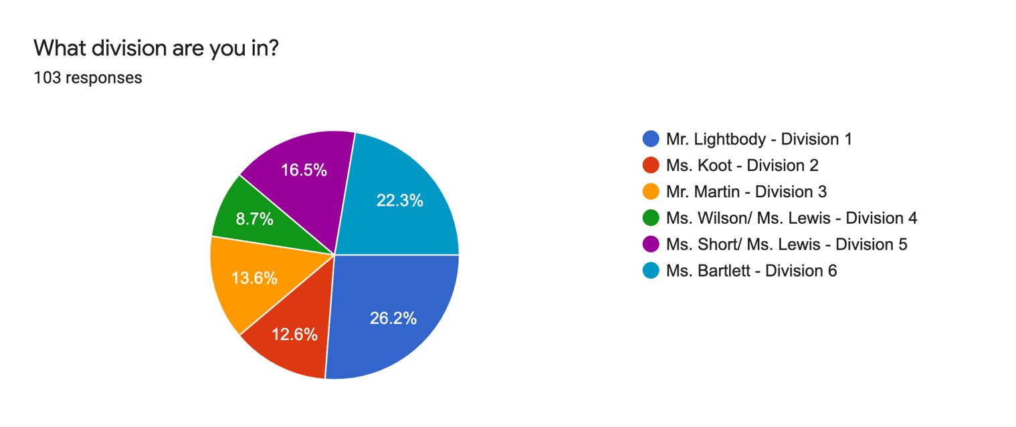
a) Using the graph above as a guide, draw a line and match the number of students who voted to their division

Division | Number of Students Who Voted
Division 1 | 13
Division 2 | 9
Division 3 | 23
Division 4 | 27
Division 5 | 17
Division 6 | 14

b) What is the “range”/spread of the data? (Refer to “Graph Info Week 7” Notes)

c) Using this data, what is the “mean”/average number of votes per class? (Refer to “Graph Info Week 7” Notes)

Given the following data, carefully consider what kind of graph would best represent this data, then make it! As last week, please ensure that your graph is: titled, neatly coloured, utilizes labels and a legend if necessary.

What Is the Best Kind of Movie to Watch
Type of Movie | Number of Students Who Voted For It
Action | 32
Romantic Comedies | 5
Scary | 12
Anything Disney+/Neflix | 7
I’d Rather Read a Book/ Spend Time with Family | 44

