EXPLORING STYLES OF MODERN ART

Around 1900, everyday life in Europe and North America began to change very quickly. Many changes came from new machines and inventions such as telephones, automobiles and airplanes. These changes were the beginning of the Modern Age.

Modern art is very much like modern life. Artists have invented many new ways to create paintings, sculpture and other kinds of art.

Your assignment this week is to explore four different styles of modern art in order to become familiar with what defines each (look at similarities and differences). Once you have come to understand, and hopefully appreciate, these four styles, you will create an original composition.

Take time to really look at a minimum of TWO compositions created by each of the artists listed.

For each of the 4 styles of fine art, choose one favorite artist and his/her compositions that you find impactful. It must make you feel or think about something…you should feel ‘drawn in’. Then answer the following questions in complete sentences:

1. How does this work of art make me feel?
2. Does this piece of art remind me of something? an idea?
a feeling? an experience?
3. Are there objects in this work of art? If so, what are they?
4. Why are they there and what do they say?
5. What story does the picture suggest?
6. Why do you like it? Why do you think that it engages or pleases you?

While looking at books or on-line resources pay particular attention to the elements and principles used, consider the subject, theme and mood of each composition that you choose.

DAY 1: ABSTRACT
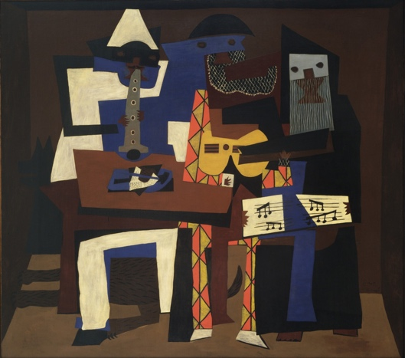
Pablo Picasso was one of the most inventive artists in modern times. One of his paintings “Three Musicians” is an example of a style of art called Abstraction. Try to identify some of the geometric shapes which represent the three musicians. Note that the overlapping shapes, patterns, contrasts and inventive use of color are similar to the inventiveness of jazz music. Artists create abstract art by using unusual lines, shapes of patterns to show things they see or remember. While there is a recognizable subject, the shapes, lines, colors and patterns are inventive. Parts are often rearranged, added or left out.

Research: Please Circle the Artist you have looked at and identify the title of the pieces you looked at: _________________________________________ & __________________________________________
Artists of this School include: Georges Braque, Juan Gris, Fernand Leger, Marcel Duchamp, Lyonel Feininger, John Marin and Henri Matisse

1. How does this work of art make me feel?

2. Does this piece of art remind me of something? an idea?
a feeling? an experience?

3. Are there objects in this work of art? If so, what are they?

4. Why are the objects there and what do they say?

5. What story does the picture suggest?

6. Why do you like it? Why do you think that it engages or pleases you?

DAY 2: EXPRESSIONISM
Expressionism is another style of modern art. In this kind of artwork, the artist expresses ideas about joy, sorrow, anger or other feelings. Edvard Munch’s painting “The Scream” is an example of this style. Notice how the curved lines and shapes help us imagine that we can hear the echo of the cry. Strong feelings or emotions are expressed through the choice of shapes, lines and color. Important parts are often exaggerated.

Research: Please Circle the Artist you have looked at and identify the title of the pieces you looked at: _________________________________________ & __________________________________________
Artists of this School include: Paula Modersohn-Becker, Ernst Ludwig Kirchner, Kathe Koolwitz, Emile Nolde, Jose Clemente Orozco, Diego Rivera and George Rouault

1. How does this work of art make me feel?

2. Does this piece of art remind me of something? an idea?
a feeling? an experience?

3. Are there objects in this work of art? If so, what are they?

4. Why are the objects there and what do they say?

5. What story does the picture suggest?

6. Why do you like it? Why do you think that it engages or pleases you?

DAY 3: NON-OBJECTIVE
Wassily Kandinsky’s “Composition Storm” and Piet Mondrian’s “Victory Boogie Woogie” are examples of Non-objective art. The paintings do not show objects or other recognizable things.
Kandinsky has used a variety of lines, colors and shapes to create an action-filled painting. The visual energy is meant to imply the energy released in a storm.
Mondrian has used only vertical and horizontal lines, squares and rectangles. The patterns and paths of movement created a visual rhythm. These artists believed that ideas and feelings could be expressed by using only lines, colors and shapes.

Research: Please Circle the Artist you have looked at and identify the title of the pieces you looked at: _________________________________________ & __________________________________________
Artists of this School include: Naum Gabo, Ben Nicholson and Kasimer Malevich

1. How does this work of art make me feel?

2. Does this piece of art remind me of something? an idea?
a feeling? an experience?

3. Are there objects in this work of art? If so, what are they?

4. Why are the objects there and what do they say?

5. What story does the picture suggest?

6. Why do you like it? Why do you think that it engages or pleases you?
DAY 4: FANTASY
Marc Chagall and many other artists have tried to show dreams and imaginary places. This style of art is called Fantasy Art. Chagall’s “I and the Village” is a great example of this dreamlike composition. He uses strong colors; large basic shapes; and playful, curving lines to express childhood memories of his village. Consider what he conveyed by making his painting unrealistic rather than showing the village as it really looked? Note the way the recognizable scenes are combined in strange, unrealistic sizes, showing positions and relationships as they often are in a dream.

Research: Please Circle the Artist you have looked at and identify the title of the pieces you looked at: _________________________________________ & __________________________________________
Artists of this School include: Giorgio de Chirico, Salvador Dali, Max Ernst, Paul Klee, Rene Magritte and Joan Miro

1. How does this work of art make me feel?

2. Does this piece of art remind me of something? an idea?
a feeling? an experience?

3. Are there objects in this work of art? If so, what are they?

4. Why are the objects there and what do they say?

5. What story does the picture suggest?

6. Why do you like it? Why do you think that it engages or pleases you?

Modern Art Final Task:
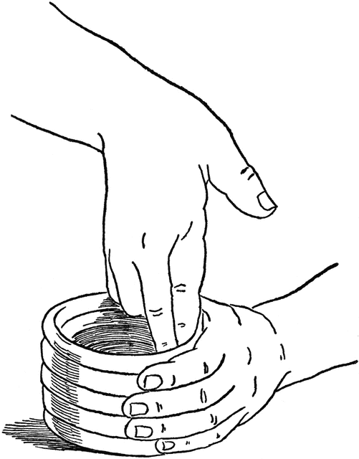
Original Composition

1. Choose one of the styles of art you researched.
2. Keep your choice a secret.
3. Consider and decide upon your:
- subject (person, place, thing, idea or a combination),
- theme (main idea) &
- mood (how you want your viewer to feel or know you are feeling)
4. Create an original composition using any process or medium you like. Remember within each style, artists create original works that have unique features.
6. Include a title for your composition

Some examples to explore could be:

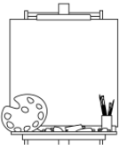
- *Abstractions might be based on a view within your bedroom or another part of your home or yard or the inventive treatment of a familiar subject (maybe a pet, person, toy or object).

- *For expressionistic works find an intense feeling and think of colors, lines and shapes. Emotions & Feelings can be powerful subjects- choose one you have truly experienced (joy, jealousy, love, grief…). Thinking of moving in your environment (walking through slushy snow, the sun’s rays on your shoulders, hot sand between your toes….). How will you represent or “express” these ideas artistically?

- *Non-objective works might be planned around curved or straight lines and shapes, with an intentional choice of colors.

- *Fantasy -works might be based on dreams or science-fiction ideas.

Higher Order Thinking – Written Extension
Our Global community has undergone a significant crisis, do you think artists are developing a New Style of Modern Art?
Explain the reasons (evidence) for your opinion.

