~DATA ANALYSIS~
Now to learn how to look at data. One of the first skills is to understand the terms of “Central Tendency” These are the ways of looking at the numbers that fall into the middle of a set of numbers. We have three different ways to measure “the middle”: Mean, Median, and Mode.

Take a look at this short video all about these data analysis terms: Math Antics on Data Sets https://www.youtube.com/watch?v=B1HEzNTGeZ4
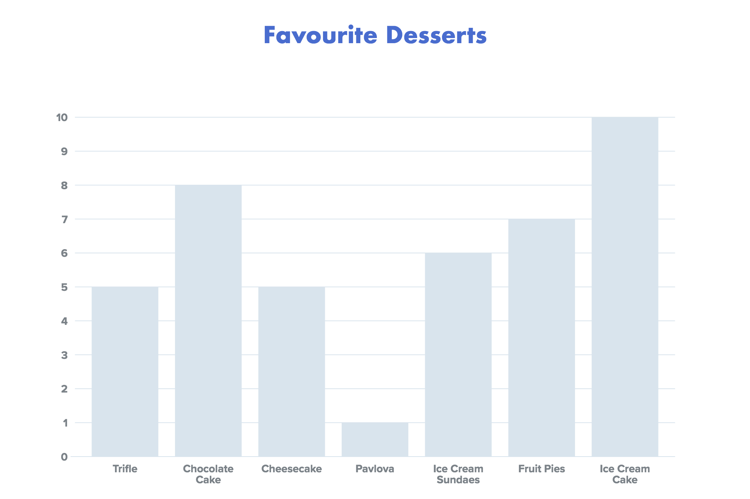
Data set: a group of numbers reflecting information about a variable. A set is always contained within brackets. For example: (4, 6, 8, 10) or (22, 34, 53, 16, 39.) Sometimes they are in numerical order, and sometimes they are not. Data Sets can also have different amounts of data points (or numbers within the set.) Favourite Desserts has a data set that looks like this: (5, 8, 5, 1, 6, 7, 10)

Mean: is the Average. You find this by adding up all of the numbers in the set, and then dividing this sum by how many numbers were in the set.
For example (5, 8, 5, 1, 6, 7, 10) Add together: 5 + 8 + 5 + 1 + 6 + 7 + 10 = 42
Divide the total by the number of data points: 42 ÷ 7 = 6 The mean of this data set is 6. The mean of any set will always fall within the range of the set; it will always be smaller than the highest value and larger than the smallest value.

Median: is the number that is in the middle position after the numbers in the set are in numerical order.
For example the set (5, 8, 5, 1, 6, 7, 10). First order the set: (1, 5, 5, 6, 7, 8, 10) There will be equal numbers of values (or data points) on each side of the median. In this arrangement you can identify 6 as the median number; there are 3 numbers below and 3 numbers above. If you have an even set of numbers, then the median is the average of the two middle numbers in the order. There will be equal numbers of values (or data points) on each side of the median.

Mode: is the value occurring most often. (Think “Mode=Most.”) For this you need to see which number has been repeated most often. Some sets will not have a mode, and others will have more than one mode. In the example (1, 5, 5, 6, 7, 8, 10) 5 appears most often.

Range: is a term that describes the “spread” of the data. It is the difference between the highest value and the lowest value. Range does not describe what is typical about the data as the Central Tendency does - it is looking at how far away are the ends of the numbers. To find the range is easy if your set is in numerical order - what is the first data point? What is the last data point? Subtract your first from your last and this is your range. For example: (1, 5, 5, 6, 7, 8, 10.) First data point is 1, and the last is 10. Therefore: 10 - 1 = 9 The Range is 9

Outliers or Data Point Extremes: An outlier is a data point that lies an abnormal distance from other values in a random sample from a population. Occasionally these can be an error, and in some situations, they are removed from the data sets as they can have significant impact on the other data analysis of their set.

All of these terms help us to understand the data in different ways. Knowing how to look at data and read graphs allows you to be a more literate person. We find graphs in all print media. Understanding how to read them and how they can manipulate data is an important skill.

Sample Questions for Favourite Desserts:
Data Set: (5, 8, 5, 1, 6, 7, 10) See bar graph above.

- What percent of people prefer Ice cream Desserts?
Ice cream cake + ice cream sundaes = 10 + 7 = 17 people
17 of 42 students surveyed prefer Ice cream desserts (add all numbers to find how many were surveyed). Now find the percent 17 ÷ 42 x 100 = 40%

- What is the ratio of students wanting desserts with whipping cream to students wanting non whipping cream treats?
Trifle, pavlova, and sundaes all use whip: 5 + 1 + 6 + 12
So the ratio would be 12 : 42 In lowest terms (divide both by 6) it becomes: 2:7

- How many students are not eating Dairy?
Fruit Pies: 7 So 7 : 42 or 1:6 or as a percent 7÷42 x100= 16%

- How many more people enjoyed fruity desserts than other kinds?
Trifle, pavlova, and fruit pies have fruit: 5 + 1 + 7= 13 If we include a fruit cheesecake our number would go up to 18 of 42. 43%

How might these statistics alter how a restaurant orders or makes desserts?

