Name: _______________________-
Date: ________________________

How Many Krispy Kremes Are There?
PART 1: Using the photos provided, estimate how many Krispy Kreme Doughnuts you think are in the box.
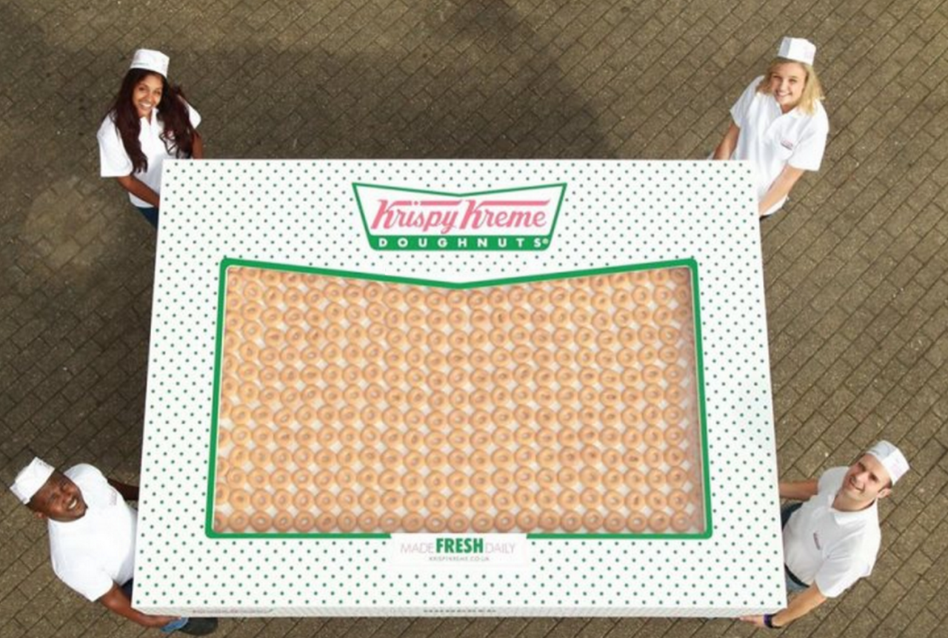
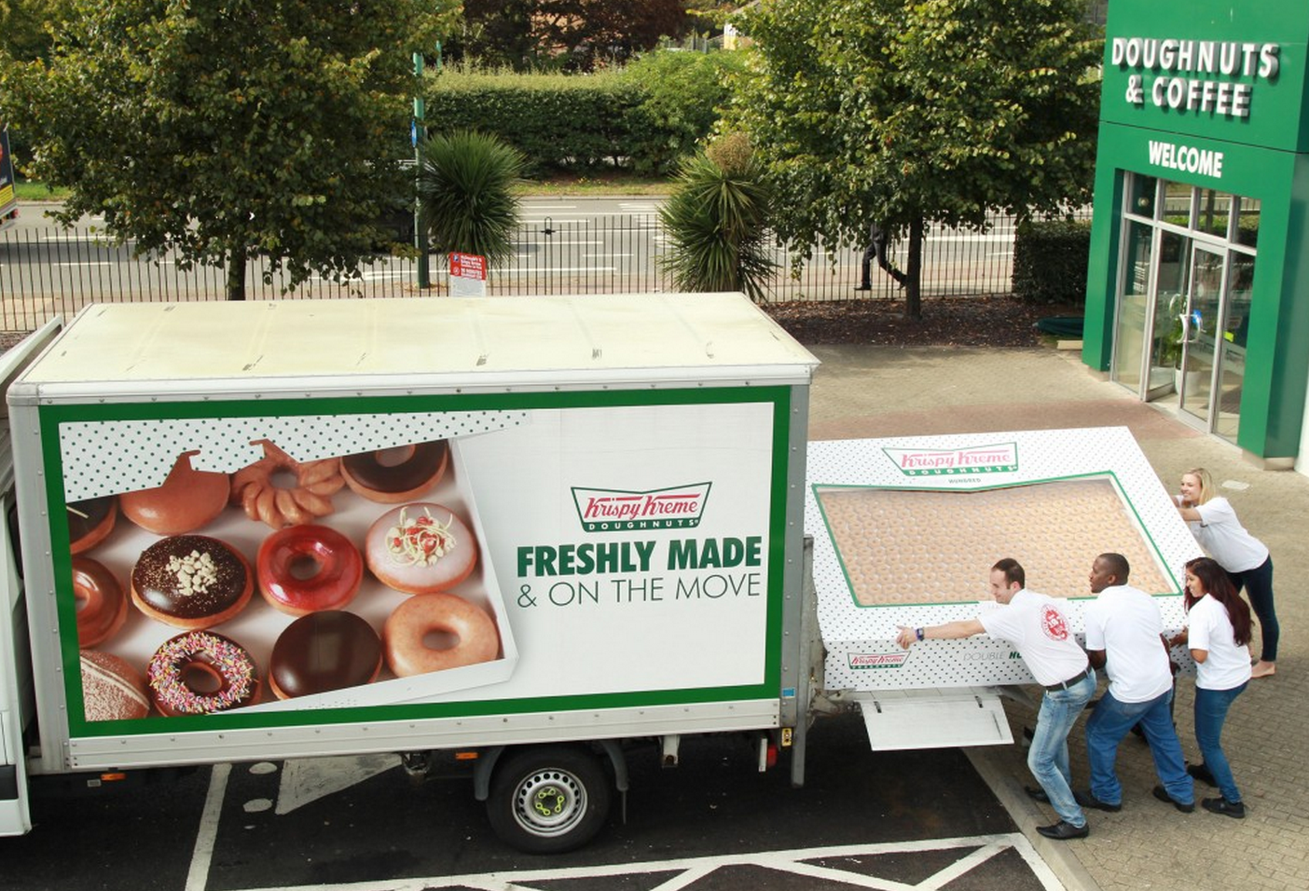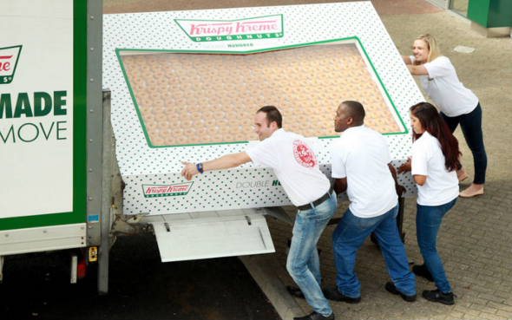
1) What is your estimate? And why?

PART 2: Once you have filled out your estimate, go to the following website and read the email that was sent by Krispy Kreme to a customer that had purchased this box of doughnuts

http://bit.ly/krispykremeemail

2) After reading this email, what is your new estimate and why?

PART 3: Watch the news video on YouTube, and find out how many doughnuts there actually are!

http://bit.ly/krispykremeyoutube

3) Were you surprised by the amount of doughnuts there were? How close in your estimate were you? Would you ever buy that many doughnuts?

