King of Clutch
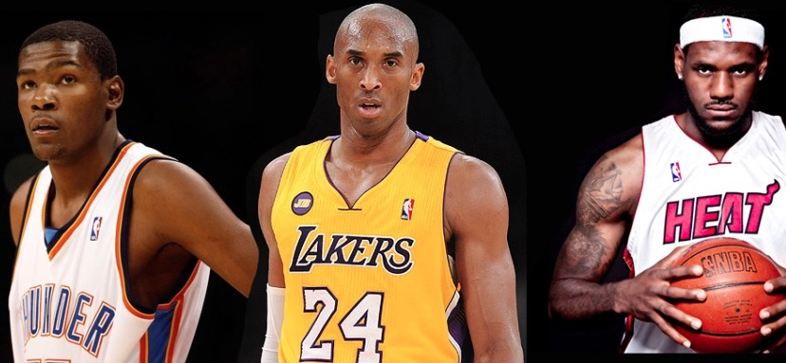
Basketball is often a fast-paced, high-scoring game with teams trading baskets throughout each quarter. In close matchups, the winner of a game can be determined by a single shot in the final seconds. This is what we in the sports world call, “clutch.”
(In Order: Kevin Durant, Kobe Bryant & LeBron James)
In this activity you will determine who, among these three great basketball talents, is the most “clutch” in their approach to basketball.
ACT 1 – Watch the video below and make a guess as to who you think would be the most “clutch”.
https://youtu.be/BxxTZYLJ344
1. Who do you guess would be the most clutch and why?
2. Who do you think would be the least clutch and why?

ACT 2 – Think critically! Make a short list of the kind of information would you need to know to figure this out.
- ______________________________
- ______________________________
- ______________________________
- ______________________________
- ______________________________
- ______________________________

Use the following link to check out their respective Playoff Statistics and Shooting Percentage in the last 24 seconds of the 4th Quarter
https://bit.ly/kingofclutchact2

What are the shooting percentages (fraction) given for each player? And what would their shooting percentage be?
Kevin Durant - ___________ (fraction) = ____________ (decimal) = __________%
Kobe Bryant - ___________ (fraction) = ____________ (decimal) = __________%
LeBron James - ___________ (fraction) = ____________ (decimal) = __________%

ACT 3 - Watch the video below to see the “King of Clutch” in action.

https://youtu.be/S_f_aiD0WYA

1. What does the shooting percentage in the 4th quarter statistics tell you about the overall pressure in those moments? Are the percentages higher or lower than you expected?

2. When you look at the playoff statistics of each player, in your opinion, which statistic matters the most (total points, total rebounds or total assists)? Why?

Extension:
Among these three, who is the leader in each category (points, rebounds, assists) on a per game basis? Show your work.

