Name: _________________
Date: __________________
Addition Crossword
Add up the numbers so that the crossword is true and makes sense!
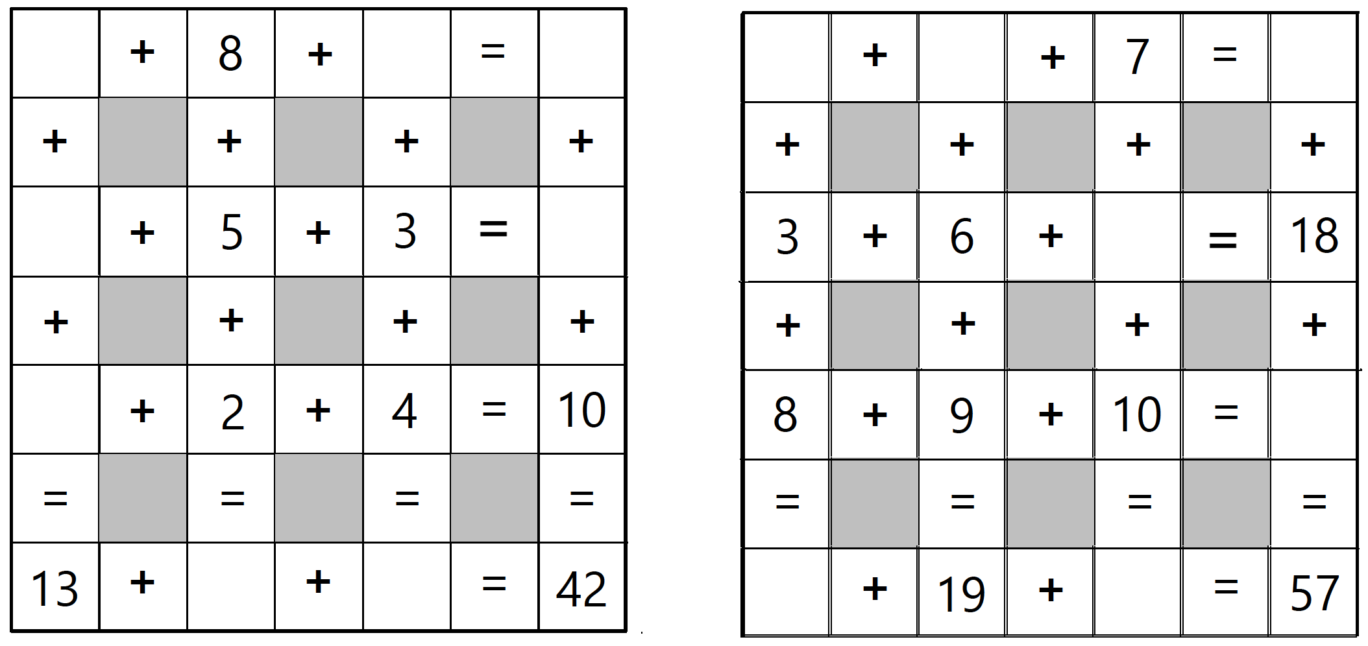
Magic Squares
Two weeks ago, you were given the magic number. This week, you will be given one square with the magic number, and one square without the magic number. Can you figure out what it is? Remember that the sum of every row, column and diagonal must be the same. Good luck!

Magic Number - 15

