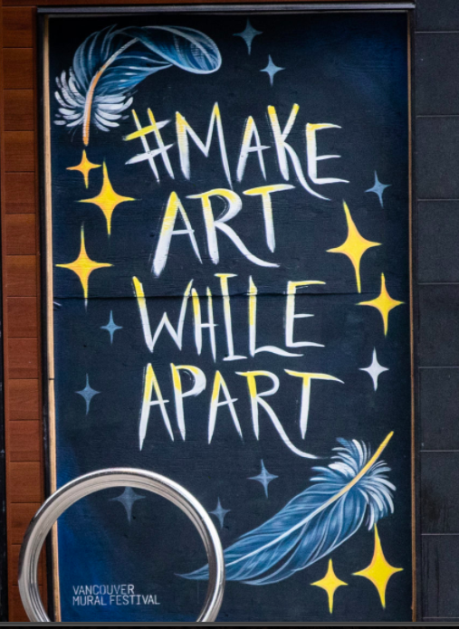
Make Art While Apart
Vancouver artists are transforming boarded-up storefronts into art during the COVID-19 pandemic

Did you know? A mural can initiate change through public awareness, creating dialogue, highlighting a community’s identity, including its successes and challenges. The City of Vancouver is helping to fund artists to paint murals on boarded storefronts with messages of thanks and hope.

PART 1:

Please go to vancouversun.com as well as to https://newsinteractives.cbc.ca/longform/make-art-while-apart to see some of the murals that honor our most recent heroes. You can also view the murals on the PowerPoint slide show. Then take a screen shot (shift+command+4) of a mural that speaks to you or captures your attention. Write and attach a caption for the mural in no more than 20 words.
Bonus: Taking the time to view important muralists throughout history can help you to understand the mural as a vehicle for social expression and change. Check out Diego Rivera’s work as one kind of example.

PART 2:
“Even when we’re apart we are together.” Signs of support…they are everywhere.
Create your own ‘mural’ to show how we are staying together, even while we are apart. Your mural should show people distancing while supporting others. Be creative!

Use whatever mediums you have available (pencil crayons, felts, crayons, paint, etc…). Your mural should fill a regular size sheet of paper (8 ½ X 11) and be bold, bright and eye-catching. You may want to do a draft sketch first so you can plan out your idea and work on spacing, composition, lettering, etc….

Give your mural a title and write a short paragraph describing the inspiration for your artwork. What message are you trying to convey? Why did you select the image(s) that you did? What would you like people to think when they see your mural? Your completed paragraph should be 5-7 sentences in length. Be sure to edit for clarity, spelling, punctuation, etc…
