Chessboard Problem:
Square Size | Number of that kind of square
8x8= | 1
7x7= | 4
6x6= | 9
5x5= | 16
4x4= | 25
3x3= | 36
2x2= | 49
1x1= | 64
Total number of squares | 204

Addition Crossword
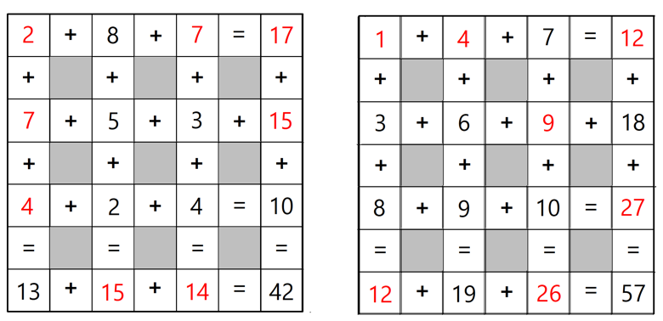

Magic Squares

WODB Food (answers include, but NOT limited to):
- 4 central holes, not edible, 3D- but thin/flat, 4 lines of symmetry
- Single central hole, not symmetrical (icing not even), dessert?
- Triangular, multilayered, many components (bread, lettuce, cheese, tomato), 3 vertices, contains right angles
- Segmented shape, ½ of a sphere, 8 lines of symmetry, 24 vertices (3 per segment)

WODB Whole Numbers #2 (answers include, but NOT limited to):
- Single digit, 3², smallest value of group, largest number in the ones place
- Divisible by 4, prime factors are all even (2x2x2x2), 4², can divide into half evenly, has 5 factors (1,2, 4, 8, 16)
- Divisible by 5, 5², factor of 100, represented in Canadian coins,
- Not a “perfect square”, not part of ordered set (3², 4², 5²), prime, 10’s place has a larger digit than ones place, largest value of the group

