NINE HOLE GOLF COURSE

Prince George is getting a new 9-hole golf course, which is going to be built on a treed lot just outside of town. Your task is to come up with a layout for the golf course.

Here are a few things that the owners of the golf course would like you to keep in mind:

- par is the number of shots required of complete a hole in regulation
- there must be two par-3 holes, five par-4 holes, and two par-5 holes
- a par-3 must be between 150 and 200 metres in length
- a par-4 must be between 250 and 400 metres in length and can have a bend in it
- a par-5 must be between 400 and 500 metres in length — at least one par-5 must have a bend in it
- all fairways are between 50 and 100 metres wide
- hole #1 must start near the clubhouse and hole #9 must end near the clubhouse
- can never be two par-3 holes or two par-5 holes in a row
- successive holes should follow each other closely
- a pond in the middle of the property that you need to work around
- there must be some trees left on the property
- must include a clubhouse and a parking lot

To help you with your design and layout you have been provided with a scaled map of the property (every square is 50m x 50m). Present your final design on a copy of this map.
- number the holes
- indicate tee boxes with the letter T
- indicate greens with the letter G
- indicate trees that are going to be left with the letter X
- indicate the clubhouse with the letter C
- indicate the parking lot with the letter P

Here are some hints:
- golf course designers often place the clubhouse near water — it is pretty
- you may want to have the parking lot and clubhouse near the edges or corners of a property
- feel free to print and complete by hand — this is probably the best way to do the activity
- if you cannot print used lined or graph paper and a ruler to make a 16 x 10 grid
- to do on the computer use Insert to put in text boxes for the letters and shapes for the arrows
- there is more than one grid as you may need to experiment a lot — you do not have complete more than one design
- make sure our final design is clear and legible
- how you complete the golf course is up to you — just follow the rules
- below I have shown how you could start the golf course

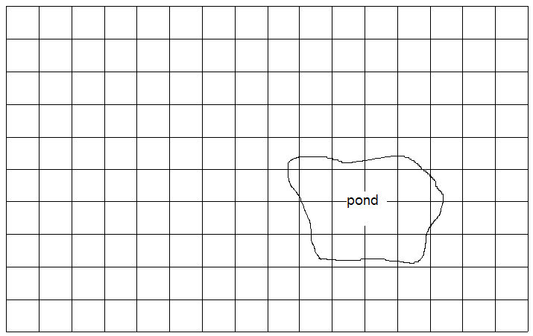
x
x

x
x
P
3
G
T
2
G
T
1
G
T
C
P
P
Hole #1 — par 4 — 300 metres
Hole #2 — par 3 — 200 metres
Hole #3 — par 5 — 450 metres
Hole #4
Hole #5
Etc.

Nine Hole Golf Course – work grid

Design your Golf Course

Complete the following chart
Hole #1 — par ______ — length = __________ m
Hole #2 — par ______ — length = __________ m
Hole #3 — par ______ — length = __________ m
Hole #4 — par ______ — length = __________ m
Hole #5 — par ______ — length = __________ m
Hole #6 — par ______ — length = __________ m
Hole #7 — par ______ — length = __________ m
Hole #8 — par ______ — length = __________ m
Hole #9 — par ______ — length = __________ m

Answer the following: If an acre of land is equal to 4046.86 m², how many acres does the entire property cover (round your answer to the nearest acre)? _____________ acres

Nine Hole Golf Course – work grid

Design your Golf Course

Complete the following chart
Hole #1 — par ______ — length = __________ m
Hole #2 — par ______ — length = __________ m
Hole #3 — par ______ — length = __________ m
Hole #4 — par ______ — length = __________ m
Hole #5 — par ______ — length = __________ m
Hole #6 — par ______ — length = __________ m
Hole #7 — par ______ — length = __________ m
Hole #8 — par ______ — length = __________ m
Hole #9 — par ______ — length = __________ m

Answer the following: If an acre of land is equal to 4046.86 m², how many acres does the entire property cover (round your answer to the nearest acre)? _____________ acres

