Name: ________________________
Date: _________________________
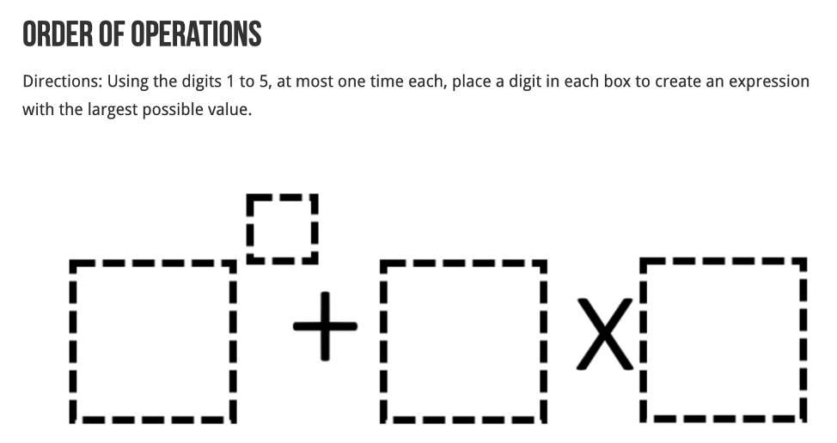

Hint: Where would you put your largest number? Use a calculator, if you need to!
Remember Order of Operations (BEDMAS – Brackets, Exponents, Division/Multiplication, Addition/Subtraction)

