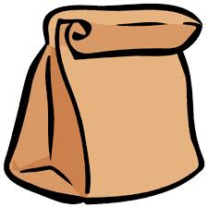

Paper Bag Project Checklist
Activity: | Suggested  Timeline: | Check:
I have created an original, relevant illustration for the front cover of the bag and included the author’s name and any special awards or recognition (ie. Newberry Award)  (*use blank white paper and colour the illustration fully.  Glue this to the front of your bag/container) | Monday,  May 4th
I have drafted a summary of the characters, setting and conflict in the story. (Three short paragraphs.) My writing is original and not copied from the summary on the novel. | Tuesday,  May 5th
I have neatly printed or typed out the summary on white paper so that it fits the width of the paper lunch bag or other available bag/container. | Wednesday, May 6th
I have added text features such as headings and mini illustrations to the summary.  *Glue your good copy to the back of your bag/container. | Wednesday, May 6th
I have found 2 objects that help to represent meaningful elements of the story and placed them inside the paper bag. | Thursday,  May 7th
I have created 6 objects that help to represent meaningful elements of the story and placed them inside the bag. | Thursday to  Tuesday,  May 7-12
I have filled out the list of objects and their meaning in the table in the project description handout. *Take a photo of this table and upload it to the Paper Bag Project activity in FreshGrade. | Wednesday, May 13
I have recorded a video of myself presenting the novel, the story summary and the 8 objects. | Thursday,  May 14
I have uploaded my video to the Paper Bag Project activity in FreshGrade (week #6) | Friday,  May 15
After you have created and selected your 8 items for the inside of your paper bag, explain each of your choices by completing the table with the name of the item and a brief description of the meaning of each item and its significance to the story.

Object: | What the object represents:
1.
2.
3.
4.
5.
6.
7.
8.

