WATCH TED TALKS
This week you will be watching TWO TEDTalks from a pre-selected list of topics and taking notes on the main ideas or themes presented in each TEDTalk. Select one TEDTalk from the list below to watch on Thursday and a different TEDTalk from the list to watch on Friday.

For each of the TEDTalks that you watch, fill in the ‘Preselected TED Talk Notes’ page.

Pre-Selected TED Talks

Acting Now on Climate Change: https://www.ted.com/talks/greta_thunberg_the_disarming_case_to_act_right_now_on_climate

Turning Negative Online Comments into Positive Offline Conversations
https://www.ted.com/talks/dylan_marron_how_i_turn_negative_online_comments_into_positive_offline_conversations#t-640662

How to Disagree Productively:
https://www.ted.com/talks/julia_dhar_how_to_disagree_productively_and_find_common_ground#t-104837

Why sneakers are like the stock market
http://www.ted.com/talks/josh_luber_the_secret_sneaker_market_and_why_it_matters#t-261014

Why are some things designed to be broken from the start?:
http://www.ted.com/talks/seth_godin_this_is_broken_1

Online clothing shopping of the future:
http://www.ted.com/talks/danit_peleg_forget_shopping_soon_you_ll_download_your_new_clothes

Social media and how it can change the world:
http://www.ted.com/talks/wael_ghonim_let_s_design_social_media_that_drives_real_change

Inside the Mind of a master procrastinator:
https://www.ted.com/talks/tim_urban_inside_the_mind_of_a_master_procrastinator
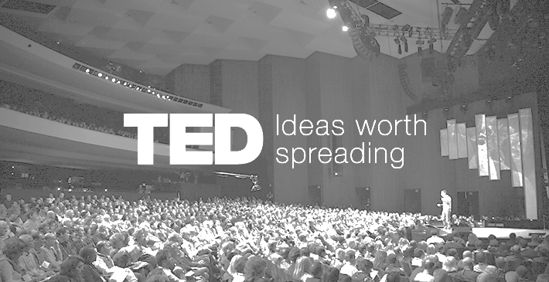

PRE-SELECTED TED TALK NOTES

Name of the TED Talk: ________________________________________________________________
Name of the Speaker: _________________________________________________________________
Topic of the Talk: ______________________________________________________________________

NOTES  (In point form, summarize the main ideas they talked about) | Identify the Themes / Connections / Big Ideas of your notes
-  -  -  -  -  -  -  -  -  - | -  -  -  -
IMPORTANT QUOTATIONS | EXPLANATION OF QUOTATIONS  (Why are they important? )
-  - | -  -
PRE-SELECTED TED TALK NOTES

Name of the TED Talk: ________________________________________________________________
Name of the Speaker: _________________________________________________________________
Topic of the Talk: ______________________________________________________________________

NOTES  (In point form, summarize the main ideas they talked about) | Identify the Themes / Connections / Big Ideas of your notes
-  -  -  -  -  -  -  -  -  - | -  -  -  -
IMPORTANT QUOTATIONS | EXPLANATION OF QUOTATIONS  (Why are they important? )
-  - | -  -
BONUS

BRAINSTORM a list of topics that you would be interested in hearing TEDTalks on. You can visit the TEDTalks website to help you get started.

http://www.ted.com/talks

