TED TALKS
Persuasive Techniques

This week you will revisit TED Talks, but this time specifically focusing on the persuasive techniques that the speaker uses in order to make their TED Talk powerful and impactful.

Part One: Monday, June 1
Begin by reviewing the Persuasive Techniques sheet that is part of this week’s package. Review the various techniques (Tone, Logical Appeal, Emotional Appeal, Connotative Devices and Stylistic Devices) to get a sense of what they are and how they are used.

Re-watch one of the TED Talks that you have already watched in Week 7. See list provided on next page. This time, pay close attention to the persuasive techniques that the speaker uses. It might be handy to have the Persuasive Techniques sheet beside you as you watch so that you can check off any techniques that you notice.

Complete the Persuasive Techniques worksheet for this talk.

Part Two: Thursday, June 3
Select 1 of TED Talks for Kids by Kids from the list in this package. Watch this TED Talk, paying close attention to the persuasive techniques. You may need to watch the TED Talk twice through – once to get the general message, and a second time to specifically look for the persuasive techniques.

Complete a Persuasive Techniques worksheet for this talk.

Part Three: Friday, June 4
Think about a topic that you are passionate about, or a subject that you would like to research and then present in the form of a TED Talk. This talk will need to be persuasive and use techniques you have learned this week. A list of possible subjects is included at the end of this package, but you may choose one not listed provided it is not the same as topics already covered in the sample TED talks provided.

Please notify your teacher of the topic you choose. Details on writing and creating a TED Talk style video will be provided next week.

***dates are a suggestion
PRE-SELECTED TED TALKS

From Week 7

Acting Now on Climate Change: https://www.ted.com/talks/greta_thunberg_the_disarming_case_to_act_right_now_on_climate

How to Disagree Productively:
https://www.ted.com/talks/julia_dhar_how_to_disagree_productively_and_find_common_ground#t-104837

Why sneakers are like the stock market
http://www.ted.com/talks/josh_luber_the_secret_sneaker_market_and_why_it_matters - t-261014

Why are some things designed to be broken from the start?:
http://www.ted.com/talks/seth_godin_this_is_broken_1

Online clothing shopping of the future:
http://www.ted.com/talks/danit_peleg_forget_shopping_soon_you_ll_download_your_new_clothes

Social media and how it can change the world:
http://www.ted.com/talks/wael_ghonim_let_s_design_social_media_that_drives_real_change

Inside the Mind of a master procrastinator:
https://www.ted.com/talks/tim_urban_inside_the_mind_of_a_master_procrastinator

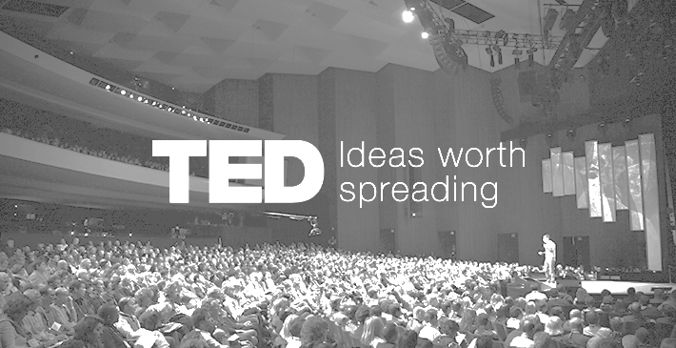

PART ONE: Look at ONE of the TED Talks you watched in Week 7. Using the persuasive technique list find 4 techniques, provide a specific example for each technique and explain how this technique assists in persuasion.
NAME OF TALK:
Technique:

Example from the talk:

How does it work?

Technique:

Example from the talk:

How does it work?

Technique:

Example from the talk:

How does it work?

Technique:

Example from the talk:

How does it work?

Summary of the Ted Talk (approximately 5 sentences)
PART TWO: Look at ONE of the persuasive TED Talks by Kids for Kids (See last page).
Using the persuasive technique list, find 4 techniques, provide a specific example and explain how this technique assists in persuasion.
NAME OF TALK:
Technique:

Example from the talk:

How does it work?

Technique:

Example from the talk:

How does it work?

Technique:

Example from the talk:

How does it work?

Technique:

Example from the talk:

How does it work?

Summary of the Ted Talk (approximately 5 sentences)
PERSUASIVE TECHNIQUES HANDOUT

TONE
Tone is the attitude of a piece of writing. It is created through the words an author chooses to use and can be positive, negative, neutral, or any other emotion.
Positive: Our new apartment is awesome!
Negative: Our new apartment is gross!
Neutral: This is the apartment we live in, it has mice.
Formal: The teacher did not understand what the students were saying.
Informal: The teacher was totally stupid, and he couldn’t even understand what students talked about.
Sarcastic: Letting kids swim without supervision is a really good idea, if you want your kids to drown.

LOGICAL APPEALS
Using logic means giving ‘reasons why’ through proof and evidence. This includes:
• Facts and Statistics • Examples • Quotations (from experts, witnesses, etc.)
Example: 95% of NBA players were 6’2 or taller when they were in high school, so height does matter.

EMOTIONAL APPEAL
You can convince your audience more drastically by making them feel things. While the Tone is the feeling of the writing, an emotional appeal is the feeling the writing creates in the reader.
• Angry • Anxious • Afraid • Sad • Proud • Excited
Example (Proud): We Canadians have a long history of being peacekeepers, not war makers.

CONNOTATIVE LANGUAGE
Our choice of vocabulary makes a great deal of difference to how our message is received. Make sure you are broadcasting the right message.
- “Sue is skinny” VS. “Sue is tiny” VS. “Sue is bone thin”
- “Jim is odd” VS. “Jim is unique” VS. “Jim is weird”
- “Carl is unmarried” VS. “Carl is a bachelor” VS. “Carl is unattached”

STYLISTIC DEVICES
Stylistic devices are tools used by writers to deliver their arguments in interesting and memorable ways. Instead of saying “He was upset”, it’s much more effective to say “He was shattered”.

Metaphor: To compare something the reader doesn’t know with something the reader does know in order to explain the unknown thing. Example: The football player was a truck when he ran through the defense.
Hyperbole: To over exaggerate for effect. Example: She spent a million dollars on shoes last year.
Alliteration: To repeat same sound or of the same kinds of sound at the beginning of words to draw emphasis to the words. Example: Hannah hits hard!
Rhetorical Question: The Author asks a question but does not expect an answer because the answer is obvious (it’s usually yes or no).
Example: Of course the people of Iraq are upset. Wouldn’t you be upset if someone bombed your home?
Parallel Structure: When you create sentences (or parts of sentences) that have a similar structure to them you add emphasis and balance to your writing.
Example: Kobe Bryant has a good crossover, a great jump shot, and an amazing knowledge of the game.
Repetition: Repeat a word/phrase to draw the reader’s attention. Example: We want less class, less school, and less work!
PERSUASIVE TED TALKS FOR KIDS BY KIDS

Choose 1, watch and complete the Part 2 worksheet.

The Power and Importance of...READING!
By Luke Bakic TEDxYouth@TBSWarsaw 3:09

https://youtu.be/rW2r5uStgG0

Kids Need Recess
By Simon Link TEDxAmanaAcademy. 3:38

https://youtu.be/Kh9GbYugA1Y

Straw No More
By Molly Steer TEDxJCUCairns 5:33

https://youtu.be/Rr5Py1r9xjw

SUGGESTIONS FOR TOPICS

- Students should not bring sugared snacks to school
- Parents must limit children’s screen time (TV, computer, tablet etc)
- School should be in session year-round
- It’s wrong to eat meat
- School recess should be longer
- School should start later in the morning
- Violent video games are more likely to make people violent
- Violent video games are dangerous
- Elementary students should have their own laptop in class
- A laptop is better than a tablet (IPad)
- Security cameras keep us safer
- The world is not doing its best to minimize CO2 emissions
- Cell phones are not safe
- Families must spend more time together
- Children must have chores (or must not)
- Going to bed early is important for the child’s health
- Why you should learn more than one language
- Students should bring pets to school
- Everyone should exercise each day
- Parents should teach children to stay on their own at home
- Pros & cons of eating sweets
- Trump is a good president
- BC Teachers deserve a raise in pay
- Surrey Schools should stop ordering pizza in hot lunches

These are suggestions - if you have another idea please notify your teacher.

