How would YOU change the world for the better?

Your assignment is to give a 3-5 minute presentation that is a call to action for the class. It can be about any subject that you would like to discuss, so long as it answers the above question and justifies your answer (it needs to argue why your idea is a good idea). It must also have an interesting TONE, use each of the STYLISTIC DEVICES, and must follow a speech format.

As you begin to research your topic, some things to think about…
History: When did it start? How long has it been happening? What are the major events related your topic? How has/have the issue(s) changed over time?
Geography: Where does the issue take place? Where is it most important? If change happened, where would the most impact be felt?
Major Players: Who are the main people/cultures/countries involved? Why does each person/group care about the topic?
Current Status: Has anyone tried to address the issue in the past? Is anyone trying to address the issue now? How is it going? What are the big arguments/disagreements about your topic?

Home Learning Suggested Schedule for your TedTalk
Week 10: Research your Topic, complete Speech Outline & Draft copy.
Now that you know your topic, find 3-4 websites to inform yourself about it and to help you come up with evidence for your argument. A good argument should be one that is not obvious, and so should have possible arguments against it. Be thinking about the Logical and Emotional appeals you can use. Be thoughtful of the language you choose. Complete the Research & Speech Outline page. Draft a first copy elaborating on the information you have already organized in your Outline.

Week 11: Complete Speech, Practice, and Record.
Revise your speech checking you have included all criteria (see Assignment Checklist). Practice. Practice. Practice. NO really. Practice. Time yourself, practice again. Record and hand in.

*You can work from cue cards, but your speech should be VERY familiar to you. You do not want to be reading your speech. You need to be looking at, and engaging with your audience.
ASSIGNMENT CHECKLIST

- NOTES & RESEARCH
  - Research Notes (3 or 4 sources)
  - Speech Outline

- SPEECH
  - Length 3-5 minutes
  - Paragraph Structure is used (separate ideas in separate paragraphs hint: each main point is a paragraph)
  - A single consistent TONE is created
  - At least 2 LOGICAL APPEALS
  - At least 2 EMOTIONAL APPEALS
  - Use of CONNOTATIVE LANGUAGE throughout
  - At least 3 STYLISTIC DEVICES
(there are 6 techniques)

- OPTIONAL Visual Aides.
You may wish to enhance your speech with visual props of your choice.

Speech should include:

- Introduction includes (1-2 paragraphs): Hook, overview of topic and your thesis

- Main Points: each become paragraphs. Each point will need evidence and connection to topic made clear and elaborated on. Be thoughtful, what language are your using to persuade? What kinds of appeals are you building into your speech?

- Conclusion (1 paragraph): Restate your thesis in different words. Summarize your arguments again briefly, and end with a call to action – what should people DO now?
My Topic: __________________________

You have a topic, now to do some Research!

Some things to think about…
History: When did it start? How long has it been happening? What are the major events related your topic? How has/have the issue(s) changed over time?
Geography: Where does the issue take place? Where is it most important? If change happened, where would the most impact be felt?
Major Players: Who are the main people/cultures/countries involved? Why does each person/group care about the topic?
Current Status: Has anyone tried to address the issue in the past? Is anyone trying to address the issue now? How is it going? What are the big arguments/disagreements about your topic?
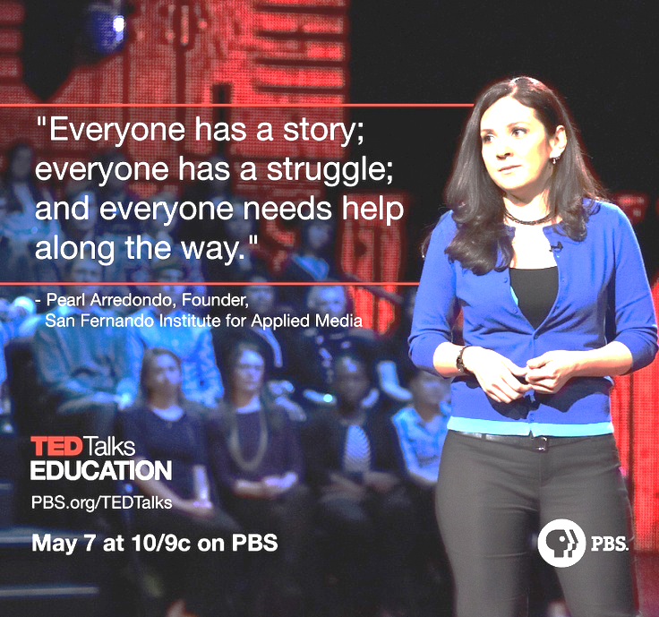
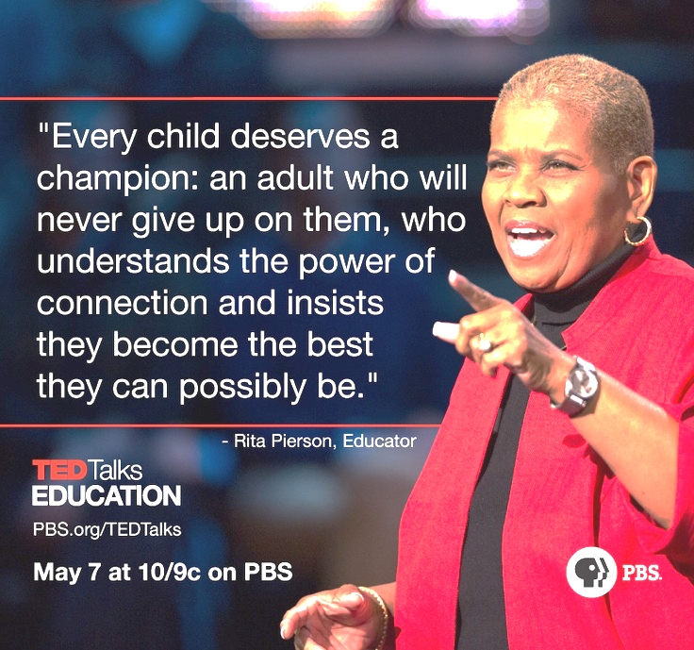

l

SOURCE 1 (website address, etc.):
What you learned from the source:

Evidence/Quotations/Statistics you might use:

RESEARCH NOTES

SOURCE 2 (website address, etc.):
What you learned from the source:

Evidence/Quotations/Statistics you might use:

SOURCE 3 (website address, etc.):
What you learned from the source:

Evidence/Quotations/Statistics you might use:

SOURCE 4(website address, etc.):
What you learned from the source:

Evidence/Quotations/Statistics you might use:

SPEECH OUTLINE
- Hook: Start with something that grabs the audience’s attention & sets the Tone:
- Share a brief story or example that directly relates to the speech.
- Mention a startling statement, statistic or fact.
- Start with a question, quotation, or familiar saying that has to do with the topic of the speech.

- Give a brief overview of your TOPIC, and connect it to your audience.

- State the Thesis: How would you change the world, & why would you change it that way?

- Main Points: Select four main points you want to emphasize.
- A point can be expressed in many different ways – examples, stories, quotations, statistics.
- Remember: You should state your point, give evidence that proves it, and then explain how the evidence works to prove that point (and how it all connects to your thesis argument).

Main Point 1:

Main Point 2:

Main Point 3:

Main Point 4:

- Conclusion: Summarize your arguments, restate your thesis, and leave them with something to think about: Use a brief story, example, or quotation. What should they do now?

________________________________________________________________________________________________________________________________________________________________________________________

SPEECH DRAFT Checklist

Speech Writing
- Strong thesis
- Organization: ideas into paragraphs, paragraphs
supported with evidence
- Proof reading and editing completed: spelling, grammar & punctuation- with very few errors.

Persuasive Techniques Used (see handout for reference)
- Clear consistent Tone:
- Minimum 2 Logical Appeals
- Minimum 2 Emotional Appeals
- Connotative Language throughout
- Minimum 4 Stylistic devices (there are 6)

Oral Communication
- Body Language – expressive, enthusiastic (or fitting tone)
- Facial Expressions – engaging and suitable for tone
- Eye contact – regular and extended. Speech largely memorized, notes available to keep on track.
- Volume, expression, and pacing – voice is clear, good pace and communicates how the presenter feels about their topic.

Visual Aides (optional)
- Visually appealing
- Organized to support speech
- Variety of meaningful images or text in supporting and connecting points to topic
- Does not include the speech on the slides.

