Name: __________________ Date: __________________________

Thumbs on Fire
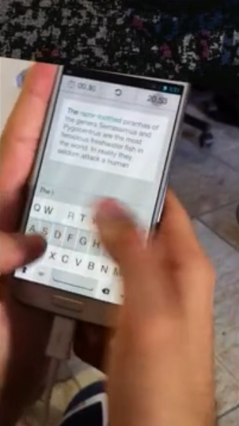
PART 1: Watch “Thumbs on Fire Act-1”: https://vimeo.com/99371274 and answer the questions before continuing with “Act 2”. You may “Rewatch” Act-1, if it will help with your estimations.

How many seconds do you think it would take to complete that text message? What’s your estimate?
Consider:
- How many words there are
- The length of the words
This is the Guinness World Records texting prompt that the texter wrote in the video.
The razor-toothed piranhas of the genera Serrasalmus and Pygocentrus are the most ferocious freshwater fish in the world. The razor-toothed piranhas of the genera Serrasalmus and Pygocentrus are the most ferocious freshwater fish in the world. In reality they seldom attack a human.

- The speed of the person texting

1) Estimate: _________________seconds
Why? What would your highest estimate be?

What would your lowest estimate be??

What do you think is a reasonable estimate?

PART 2: “Thumbs on Fire Act -2” gives you a closer look at the text message. https://vimeo.com/99369909
2) Does this information change your original estimate? If so, how does it?

3) What is your Revised estimate?

PART 3: Watch the video to see how long it took to write the whole text message!
https://vimeo.com/99367439
3) Were you right? What factors do you think affected your original estimate?

Go to” typingtest.com” on your phone and you are able to TEST YOURSELF – how fast are YOU?? They provide a paragraph to test how fast YOUR fingers can fly? (No app, download or signup required) www.typingtest.com (it says typing but on phones will test texting speed)

First attempt: content- __________________________. Results words _________________ errors _________________ level. _________

Second Attempt: content: _______________________. Results words _________________ errors _________________ level. _________

Third Attempt: content: _________________________. Results words _________________ errors ________________ level. _________
Observations/reflections about my timed texting:

