What Does 2,000 Calories Look Like?
They say the average adult diet should consist of around 2,000 calories per day.
But what does 2,000 calories look like? How would we even know if we ate that many calories? In your assignment, you’ll be looking at different ways to come to 2,000 calories using everyday food you might eat!
PART 1: Without using Google or an educated family member, estimate how many of each will yield 2,000 calories. For example, how many bagels would a person need to eat to consume 2,000 calories? What kind of estimate would be too high? What would be too low? What would be just right?
Food Name | Too High Estimate | Too Low Estimate | Just Right Estimate
Bagel
Glazed doughnut
Slices of bacon
Cinnabon Cinnamon Roll
Big Mac
Chicken Nuggets
Large Fries at McDonalds
Banana
Avocado
Chipotle Burrito
Cheese Pizza
Slices of Bread
M&Ms

PART 2: Watch the video
https://vimeo.com/105729196

What surprised you about that video? What did you already know?

PART 3: Using the information from the video, answer the following questions:
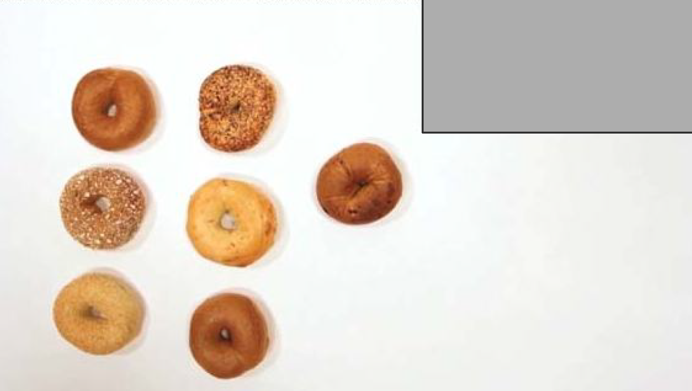
1. How many calories are in one bagel?
2. How many calories are in one Cinnabon Cinnamon Bun?
3. How many slices of bacon are equal one doughnut?
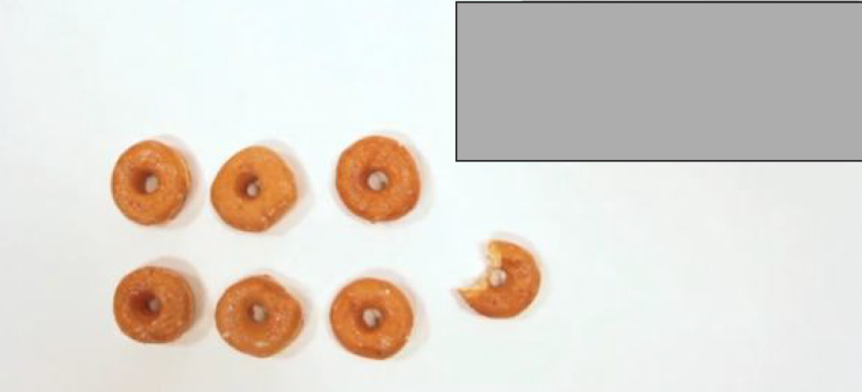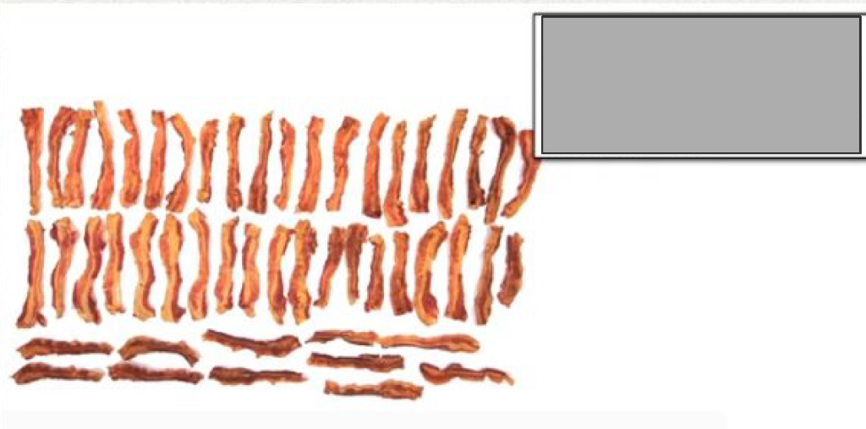

4. Using Google, find out how many calories a day a person your age should be eating. ____________ calories
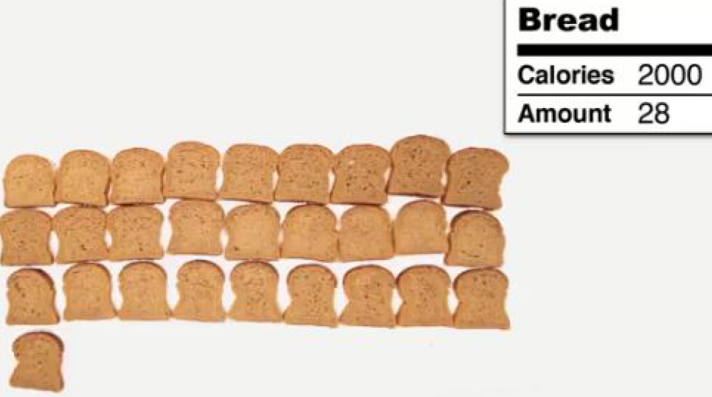
If you had already eaten 850 calories, what is the maximum number of slices of bread you could eat if you wanted to eat exactly the amount of calories someone your age should eat.
Reflection Questions
1. Did any of these facts surprise you?
2. What does it mean to you when you see how many slices of bacon equal one doughnut?
3. What is one math takeaway from this activity? What is one lifestyle takeaway from this activity?

