Which One Doesn’t Belong

Many of you have already played Which One Doesn’t Belong (WODB) in class. We have selected questions that use math concepts that you are familiar with. You will be thinking about the numerous reasons why each section does not belong to the set of the other 3 items. See how many you can find – there are multiple reasons for each! Record your answers ensuring you have a couple for each as a minimum.
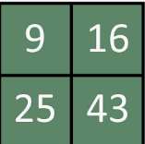
C
D
A
B
For example: Section C does not belong because it is the only number divisible by 5. (The rest in the set not divisible by 5)

This could also be a fun game to play with siblings, challenge your parents with.

