Writing & Art: Reflect & Express
WEEK 4
April 27 – May 1

→ You are expected to focus on this task for at least 30 minutes each day.
→ You will be adding visuals to your writing. Your visuals need to demonstrate effort, ORIGINALITY and creativity.
→ Written work needs to be descriptive and impactful (use powerful adjectives, adverbs, similes and/or metaphors). Figurative language must be used.

 | Assignment | Writing Prompts and Ideas to Expand On
Monday | Writing Topic “A Picture is Worth A Thousand Words”  (on paper or typed) | Create a web or any other graphic organizer for brainstorming powerful words or phrases describing your Moods, Feelings and/or Emotions  Next, choose three words/phrases that you feel best describe your mood today.  Then expand those ideas into powerful statements which could become captions for a cartoon, photo or sketch.  Example starters:  I feel like a wilting dandelion because…  My mood is meditative since…  I am a sloth this Saturday since…  My mood is like an out of control train…  Frantic this Friday as…  Finally, decide whether you will use photography or other tools for creating an original art image for tomorrow.
Tuesday | Writing Topic “A Picture is Worth A Thousand Words”  Create a ‘Personal Portrait’ original artwork | Take some time to truly reflect (look in a mirror if you like) on what your mood is today.  Ask yourself: What have I chosen to do today and why? How would I describe my body language? Have I interacted with others today? If so, how would I describe those interactions? What am I feeling…gratitude, sadness, hopefulness…..?  Then create an original image that visually describes your mood today using an 2D or 3D tools available.  For example:  FRUSTRATED might look like this: Or BORED: Or ANGRY:  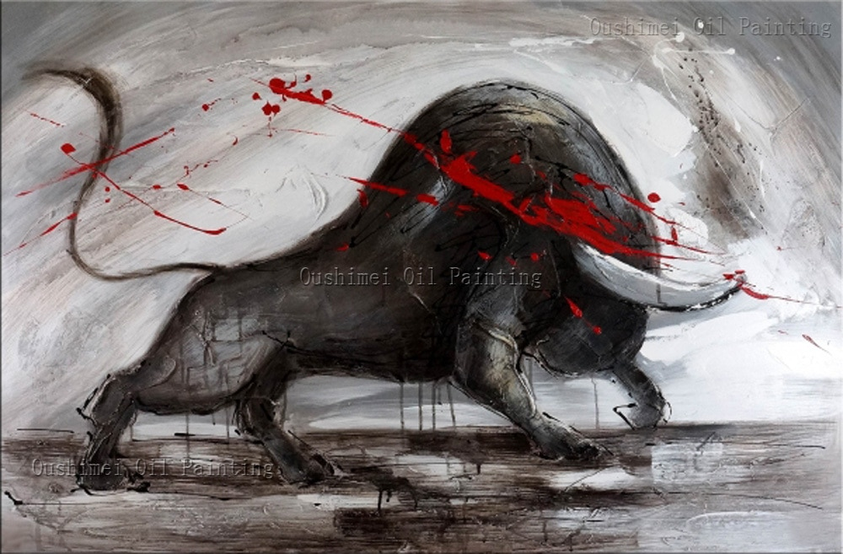  You can take a picture of yourself, or use a family member (with their permission) to be the subject. Your photo also does not need to include a person – you can take a picture of an object or create your own scene. If you’d rather create your image you can draw or paint a picture, create a collage, create a 3D sculpture out of PlayDoh… the options for expressing yourself are endless! Be creative. Experiment. Play. Express yourself!
Wednesday | Writing Topic “A Picture is Worth A Thousand Words”  (on paper or typed) | Add a brief caption for your ‘Personal Portrait’ from yesterday (5 to 10 words).  Then write a paragraph (50 to 100 words) explaining your mood and how your visual captures or represents feelings and a mood. Focus on the aspect of ‘style’ in your writing. Let’s hear your writer’s voice, use powerful language, engage your reader.
Thursday | ‘Amusement Park Fun’ | No writing task today
Friday | Pro-D Day | No writing task today

